Cell Division: Mitosis
Why do we produce new cells?

How do we produce new cells?
- The cell replicates its genetic material
- The nucleus divides into two
- The cell divides into two

What is the definition of mitosis?
Mitosis is _________________________________________________________________
_________________________________________________________________________

What are the stages involved in mitosis?

Phase of Mitosis | Description of Phase | Images of Phase
Interphase  (before mitosis) |  | 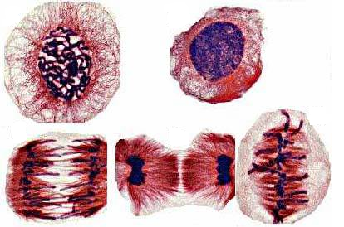  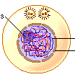
Prophase |  | 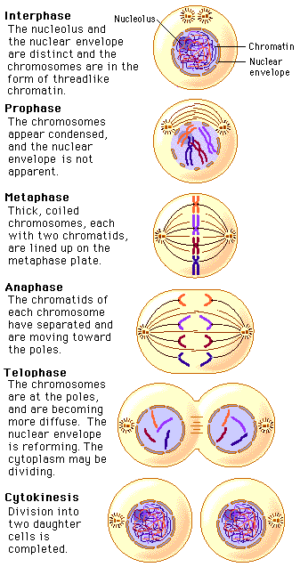
Metaphase
Anaphase
Telophase
Interphase  (after mitosis) |  | 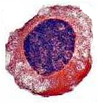

Below are descriptions of events that occur during mitosis. Identify the stage of mitosis by writing
Structure of a Chromosome
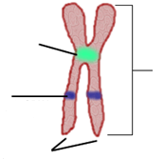

- I for interphase
- P for prophase
- M for metaphase
- A for anaphase
- T for telophase
____ The cell performs its normal functions
____ Spindle fibres attach to the centromere
____ DNA replication takes place
____ The nuclear membrane breaks down
____ The spindle forms
____ The daughter chromosomes reach opposite poles of the cell
____ New nuclear membranes form and the chromosomes start to unravel
____ The chromosomes line up onto the equator of the cell.
____ Daughter chromosomes are dragged to opposite ends of the cell
____ The cell pinches in the middle and starts to divide in two
____ The centromeres break, separating the chromosomes
____ The chromatin condenses into visible chromosomes

